**YouTube**

**Product Dissection for Youtube**

### **Company Overview:**

YouTube is a video-sharing platform that allows users to upload, view, and share videos. It was founded in 2005 and is now owned by Google (Alphabet Inc.). YouTube has become one of the most visited websites globally and has a significant impact on online video consumption, content creation, and social engagement.

### **Product Dissection and Real-World Problems Solved by Youtube:**

YouTube is a globally influential video-sharing platform that has transformed the way we access and engage with content. Its multifaceted features, such as user accounts, content upload and storage, content discovery, and community engagement, have made it a hub for sharing knowledge, entertainment, and creativity. YouTube's recommendation algorithm ensures that users discover content tailored to their interests, while its monetization strategies, including ads and subscriptions, have empowered creators and advertisers alike.

One of YouTube's most significant impacts is its role in solving real-world problems. It has revolutionised education by providing accessible, free educational content, particularly during the COVID-19 pandemic when online learning became essential. The platform has also democratised skill development and learning through its vast library of tutorials, empowering individuals to acquire new skills and tackle practical challenges. In the realm of entertainment and mental health, YouTube's diverse content offers relaxation and support, while creators often address mental well-being topics.

Moreover, YouTube serves as a vital source of news, information, and analysis, facilitating informed public discourse. It fosters economic opportunities by enabling content creators to earn income and build careers. The platform promotes cultural exchange, allowing people from diverse backgrounds to share their traditions and stories, fostering cross-cultural understanding. Finally, YouTube plays a significant role in advocacy and social impact, enabling activists and nonprofits to raise awareness and mobilise support for various causes.

In summary, YouTube's innovative features and its positive impact on education, skill development, entertainment, information dissemination, economic empowerment, cultural exchange, and social advocacy make it an indispensable platform that continues to solve real-world problems and shape our digital landscape.

### **Case Study: Real-World Problems and Youtube Innovative Solutions**

YouTube, a leading video-sharing platform, has not only revolutionised the way we access and share video content but has also addressed significant real-world challenges through its innovative features. By identifying user needs and harnessing advanced technology, YouTube has established itself as a solution-driven platform that democratises education, empowers creators, promotes global understanding, and serves as a hub for diverse content.

#### **Problem 1: Limited Authenticity in Digital Storytelling**

**Real-World Challenge:** In the digital age, maintaining authenticity in storytelling can be challenging, as text-based content often falls short in conveying genuine emotions and experiences.

**YouTube's Solution:** YouTube recognized the need for authentic digital storytelling. By allowing users to create and share video content, including vlogs, documentaries, and personal narratives, the platform provides a rich and immersive medium for users to express themselves authentically. Video content captures emotions, body language, and real-life experiences, enabling content creators to connect with their audience on a deeper and more genuine level.

#### **Problem 2: Navigating the Complexity of Video Content**

**Real-World Challenge:** The vast amount of video content available online can overwhelm users, making it challenging to discover relevant and engaging videos aligned with their interests.

**YouTube's Solution:** YouTube addresses the issue of content discovery through its innovative recommendation system. By using advanced algorithms, the platform curates personalised video recommendations for each user based on their watch history and preferences. This intelligent recommendation system ensures that users encounter videos, channels, and topics that resonate with their interests, helping them navigate the complexity of video content and enhancing their viewing experience.

#### **Problem 3: Empowering Diverse Content Creators**

**Real-World Challenge:** Many talented individuals aspire to share their creativity and expertise through video content but may struggle to find a platform to showcase their talents and reach a broader audience.

YouTube's Solution: YouTube empowers content creators from diverse backgrounds and interests by providing a platform where they can share their talents and passions. Whether it's music, gaming, education, or DIY tutorials, YouTube offers a space for creators to publish their content, gain subscribers, and potentially monetize their videos. This solution not only provides an avenue for personal expression but also encourages the growth of a diverse community of content creators.

#### **Problem 4: Expressing Personal Brand and Identity**

**Real-World Challenge:** Establishing a unique online identity can be challenging, as traditional text-based platforms may limit personal branding opportunities.

**YouTube's Solution:** YouTube offers content creators a comprehensive channel space that includes branding elements such as profile pictures, channel banners, video thumbnails, and video content. This space allows creators to express their personality, interests, and expertise visually and through their videos. Content creators can build and showcase their personal brands effectively on YouTube, solving the problem of limited personal branding on text-based platforms and fostering authentic and recognizable online identities.

#### **Conclusion:**

YouTube's evolution from a video-sharing platform to a global digital giant underscores its profound impact on addressing real-world challenges through innovation. By recognizing the need for authentic digital storytelling, simplifying content discovery, empowering diverse content creators, and facilitating personal branding, YouTube has effectively tackled several hurdles in the digital realm. This case study illuminates YouTube's commitment to user-driven solutions, showcasing how the platform has redefined the online landscape, fostering meaningful connections and transforming the way we engage with video content. As a pioneer in video-sharing, YouTube continues to shape the digital narrative and stands as a leader in the realm of digital content consumption and creation.

## 

### **Top Features of YouTube:**

1. **Video Content:** At the core of YouTube is the ability to upload, view, and share video content. Users can explore a wide range of videos, from educational tutorials to entertainment, news, and music.
2. **User Profiles:** YouTube allows users to create personalised profiles, including profile pictures, channel banners, and video playlists. This provides content creators with a platform to showcase their unique style and identity.
3. **Subscriptions:** Users can subscribe to their favourite channels, receiving notifications when new videos are uploaded. This feature fosters a sense of community and loyalty among viewers.
4. **Recommendation Algorithm:** YouTube's recommendation system suggests videos based on a user's watch history, interactions, and preferences. This feature enhances content discovery and personalises the user experience.
5. **Comments and Engagement:** Users can engage with video creators and other viewers through comments, likes, and shares. This interaction promotes community and dialogue around video content.
6. **Monetization Options:** YouTube offers various ways for content creators to monetize their channels, including ads, channel memberships, Super Chat during live streams, and merchandise shelf integration.
7. **YouTube Studio:** Content creators have access to a suite of tools for video editing, analytics, and audience engagement. This helps them refine their content and better understand their viewers.
8. **Live Streaming:** YouTube Live enables users to broadcast live video content, interact with viewers in real-time, and share events or experiences as they happen.
9. Education and Learning: YouTube serves as a hub for educational content, with many creators providing tutorials, lectures, and how-to guides on a wide range of subjects.
10. **Global Reach:** YouTube's global reach allows users to explore content in multiple languages, fostering cross-cultural understanding and global connections.
11. **Content Diversity:** The platform hosts diverse content, from gaming to music videos, from product reviews to documentaries, offering something for everyone.
12. **Accessibility Features:** YouTube offers accessibility features such as closed captions, auto-generated subtitles, and community contributions, making video content more inclusive.

### **Schema Description :**

The schema for YouTube comprises several key entities that encompass various aspects of the platform, each with specific attributes and relationships. These entities are designed to facilitate the management of content, interactions, and user experiences. Here is a description of some of the primary entities in YouTube's schema:

**User Entity:** Users are central to YouTube, and the user entity contains information about each user:

* **UserID (Primary Key):** A unique identifier for each user.
* **Username:** The chosen username for the user's account.
* **Email:** The user's email address for account-related communication.
* **Channel Name:** The user's channel name, which is displayed publicly.
* **Description:** A brief description or bio that users can use to express themselves on their channel.
* **Registration_Date:** The date when the user joined YouTube.

**Video Entity:** Videos are the primary content shared on YouTube:

* **VideoID (Primary Key):** A unique identifier for each video.
* **UserID (Foreign Key referencing User Entity):** The user who uploaded the video.
* **Title:** The title of the video.
* **Description:** A detailed description of the video's content.
* **Duration:** The length of the video in minutes and seconds.
* **Views:** The number of views the video has received.
* **Upload Date:** The date when the video was uploaded.
* **Thumbnail:** The URL of the video's thumbnail image.
* **Tags:** Keywords and phrases used to categorise the video.

**Channel Entity:** Channels represent user profiles and collections of videos:

* **ChannelID (Primary Key):** A unique identifier for each channel.
* **UserID (Foreign Key referencing User Entity):** The user associated with the channel.
* **Channel Name:** The public name of the channel.
* **Description:** Information about the channel and its content.
* **Channel Banner:** The image displayed at the top of the channel page.
* **Subscribers:** The number of users who have subscribed to the channel.
* **Total Views:** The cumulative views across all videos on the channel.

**Comment Entity:** Comments enable users to engage in discussions about videos:

* **CommentID (Primary Key):** A unique identifier for each comment.
* **VideoID (Foreign Key referencing Video Entity):** The video being commented on.
* **UserID (Foreign Key referencing User Entity):** The user who posted the comment.
* **Text:** The text of the comment.
* **Comment_Date:** The date and time when the comment was posted.

**Like and Dislike Entity:** Likes and dislikes represent user feedback for videos:

* **LikeDislikeID (Primary Key):** A unique identifier for each like or dislike.
* **VideoID (Foreign Key referencing Video Entity):** The video that received the like or dislike.
* **UserID (Foreign Key referencing User Entity):** The user who liked or disliked the video.
* **Like/Dislike:** Indicates whether the user liked or disliked the video.
* **LikeDislike_Date:** The date and time when the like or dislike was registered.

**Subscription Entity:** Subscriptions connect users with channels:

* **SubscriptionID (Primary Key):** A unique identifier for each subscription.
* **SubscriberUserID (Foreign Key referencing User Entity):** The user who is subscribing to a channel.
* **ChannelUserID (Foreign Key referencing User Entity):** The user who owns the subscribed channel.
* **Subscription_Date:** The date when the subscription was initiated.

**Playlist Entity:** Playlists are collections of videos created by users:

* **PlaylistID (Primary Key):** A unique identifier for each playlist.
* **UserID (Foreign Key referencing User Entity):** The user who created the playlist.
* **Playlist Name:** The name of the playlist.
* **Description:** Additional information about the playlist.
* **Videos:** The list of videos included in the playlist.

**Recommendation Entity:** Recommendations track video suggestions to users:

* **RecommendationID (Primary Key):** A unique identifier for each recommendation.
* **UserID (Foreign Key referencing User Entity):** The user receiving the recommendation.
* **VideoID (Foreign Key referencing Video Entity):** The suggested video.
* **Recommendation_Date:** The date and time when the recommendation was made.

**Live Stream Entity:** Live streams represent live video broadcasts:

* **StreamID (Primary Key):** A unique identifier for each live stream.
* **UserID (Foreign Key referencing User Entity):** The user who is streaming live.
* **Title:** The title of the live stream.
* **Description:** Additional information about the live stream.
* **Viewers:** The number of viewers watching the live stream.
* **Live Chat:** Enables viewers to interact with the streamer and each other in real-time.

**Closed Captions Entity:** Closed captions provide text overlays for video content:

* **CaptionID (Primary Key):** A unique identifier for each closed caption.
* **VideoID (Foreign Key referencing Video Entity):** The video associated with the caption.
* **Language:** The language of the closed caption.
* **Caption Text:** The text of the closed caption.

**Advertisement Campaign Entity:** Advertisement campaigns represent paid advertising on YouTube:

* **CampaignID (Primary Key):** A unique identifier for each ad campaign.
* **Advertiser:** The company or individual running the campaign.
* **Target Audience:** The demographic or user group the campaign is targeting.
* **Budget:** The allocated budget for the campaign.
* **Impressions:** The number of times the ad has been viewed.

**Relationships:**

* **Users upload Videos –** Each user can upload multiple videos.
* **Users comment on Videos –** Users can comment on multiple videos, and each video can have multiple comments.
* **Users like and dislike Videos –** Users can like and dislike multiple videos, and each video can have multiple likes and dislikes.
* **Users subscribe to Channels –** Users can subscribe to multiple channels, and each channel can have multiple subscribers.
* **Videos can be part of Playlists –** Multiple videos can be added to playlists, and each playlist can contain multiple videos.
* **Users receive Recommendations –** Each user can receive multiple video recommendations.
* **Users create Live Streams –** Users can create and host multiple live streams, and each live stream can have multiple viewers and live chat interactions.
* **Videos can have Closed Captions –** Videos can have multiple closed captions available in different languages.
* **Advertisers create Advertisement Campaigns –** Each advertiser can create multiple ad campaigns to reach their target audience.

**ER Diagram:**

Let's create an Entity-Relationship (ER) diagram that provides a visual representation of the relationships and attributes of the entities within the YouTube schema. This ER diagram will help illustrate the key components of YouTube's data model, allowing for a better understanding of how the platform manages content, interactions, and user experiences.

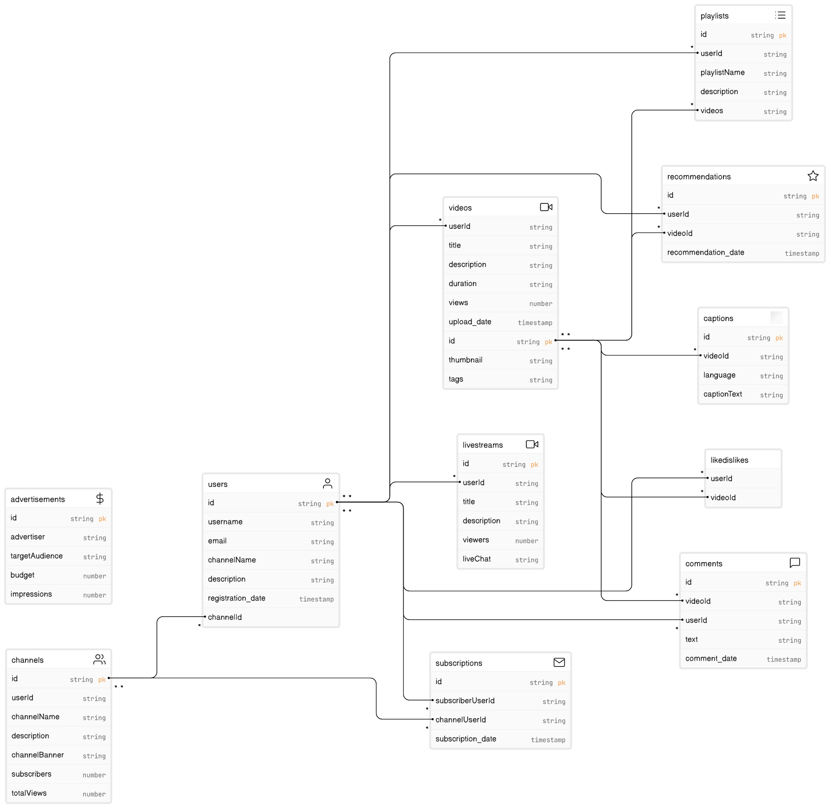

**Conclusion:**

In this case study, we've explored the design of YouTube's schema and the creation of an Entity-Relationship diagram. YouTube has redefined how people access, share, and engage with video content, enabling a vast and diverse community of content creators and viewers. The intricate data model, encompassing entities such as users, videos, comments, likes, subscriptions, playlists, and recommendations, forms the backbone of YouTube's functionality. Understanding this schema offers valuable insights into how YouTube effectively handles the complexities of content management and user engagement, contributing to its status as a global leader in the world of online video sharing.

**Submitted by : sanju nivesh **